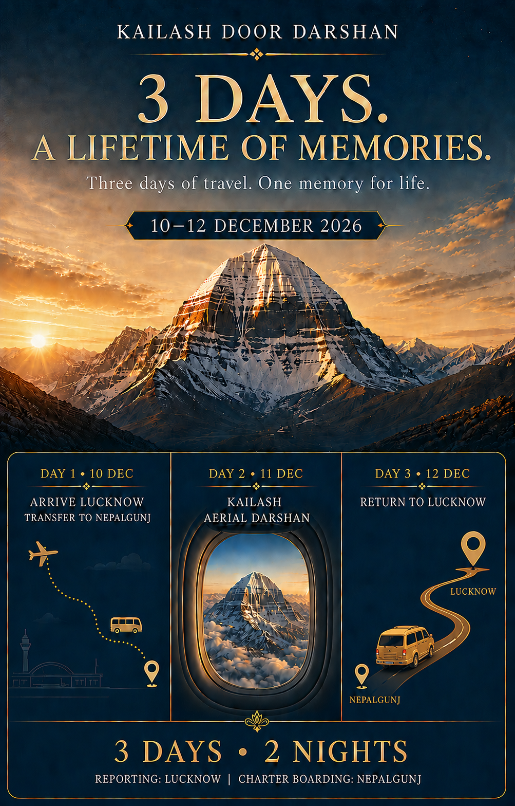
KAILASH DOOR DARSHAN
Aerial Darshan of Mount Kailash
10–12 December 2026 | 3 Days • 2 Nights

A sacred journey above the clouds
  - A thoughtfully planned three-day pilgrimage from Lucknow, centred on an aerial darshan of Mount Kailash.
10–12 DEC  December departure | 3 DAYS  2 nights | NEPALGUNJ  Charter boarding

Experience overview
This programme is designed for devotees who wish to witness Mount Kailash without undertaking the demanding overland yatra or parikrama. The journey includes coordinated transfers between Lucknow and Nepalgunj, a two-night stay, full meal support, a dedicated pandit for the flight puja, and a havan at Bageshwori Temple.

Package price
Seat category | Price per person | Flight refund if no flight operates
Window seat | ₹61,000 | ₹35,000
Non-window seat | ₹51,000 | ₹25,000
5% GST extra on the package price.
Important: The flight refund applies only when the Kailash aerial flight does not operate. The balance amount covers services already used or committed, including accommodation, meals, transfers, temple arrangements and programme operations.

Essential travel timings
- Arrive in Lucknow by 12:00 noon on 10 December 2026.
- Book your return journey from Lucknow after 8:00 pm on 12 December 2026.
- Guests arriving late or departing early must arrange any resulting private transfer at their own cost.

Your three-day journey
  - Lucknow • Nepalgunj • Kailash Aerial Darshan • Lucknow
DAY 1 | 10 DECEMBER | ARRIVE LUCKNOW • TRANSFER TO NEPALGUNJ
- Arrive at Lucknow Airport or railway station by 12:00 noon.
- Meet the tour team and proceed to Nepalgunj by shared transfer.
- Check in at Lords or a similar 4-star hotel.
- Participate in the havan at Bageshwori Temple, subject to local timings.
- Dinner and briefing for the next morning’s aerial darshan.

DAY 2 | 11 DECEMBER | KAILASH AERIAL DARSHAN
- Early breakfast and transfer for charter reporting.
- Pre-flight puja conducted by the accompanying pandit.
- Board the charter flight for aerial darshan of Mount Kailash, subject to weather, visibility and regulatory approvals.
- Return to Nepalgunj after the flight.
- Lunch, dinner and overnight stay at the hotel.

DAY 3 | 12 DECEMBER | RETURN TO LUCKNOW
- Breakfast at the hotel.
- Check out and travel from Nepalgunj to Lucknow by shared transfer.
- Lunch included during the programme.
- Plan your onward departure from Lucknow after 8:00 pm.

Meal plan
Breakfast | Lunch | Dinner | Total meals
2 | 3 | 2 | 7 meals

Before you travel
  - Practical guidance for the Lucknow–Nepalgunj journey and border entry.

Road journey advisory
- Lucknow to Nepalgunj is a long road journey. Carry ready-to-eat food, dry snacks, drinking water and any personal medicines required during the drive.
- Only one scheduled lunch stop is planned en route. Additional food stops cannot be assured and will depend on road and traffic conditions.

Weather and travel-booking advisory
- All flights booked to Lucknow and from Lucknow must be on a cancellable or changeable fare. Avoid non-refundable fares.
- The Kailash aerial flight is weather dependent. The programme dates may be rescheduled if operating conditions are unsuitable.
- If the programme must be extended, an additional charge of ₹5,000 per person, per additional day will apply.

Optional Ayodhya Darshan
₹10,000 per person | Minimum 4 paying guests required. Subject to itinerary alignment, availability and operational feasibility.

Nepal entry documents for Indian citizens
- Carry either a valid original Indian passport or an original Voter ID card with photograph issued by the Election Commission of India.
- Downloaded or online-print Voter ID, Aadhaar, PAN card and driving licence are not accepted as travel documents for this journey.
- Keep the original document readily accessible during the road transfer and border formalities.

What your package includes
  - Essential arrangements for a comfortable and spiritually meaningful journey.

Included
- Two nights’ accommodation at Lords or a similar 4-star hotel in Nepalgunj.
- Two breakfasts, three lunches and two dinners.
- Lucknow–Nepalgunj–Lucknow transfers on SIC basis.
- Force Urbania or Toyota Crysta/SUV, selected according to final group size.
- Kailash aerial darshan charter flight in the booked seat category, subject to operation.
- Pandit for the pre-flight puja.
- Havan at Bageshwori Temple.
- Special pilgrimage gift hamper.
- Basic tour coordination and on-ground assistance.

Not included
- Travel to Lucknow and onward travel from Lucknow.
- 5% GST on the package price.
- Cancellation, rescheduling or fare-difference charges for flights or trains booked to and from Lucknow.
- Personal expenses, tips, porterage, room service and services not listed under inclusions.
- Private transfers caused by late arrival, early departure or deviation from the group schedule.
- Additional accommodation, meals or transport arising from weather disruption, flight delay, force majeure or changes beyond the organiser’s control.
- Travel insurance and medical expenses.

Booking policy
- A booking amount of ₹25,000 per person is required to reserve a seat.
- The booking is confirmed only after payment and written confirmation of the selected seat category.
- The balance payment is due 30 days before departure. Bookings made within 30 days require full payment.
- Window seats are limited and allotted only against confirmed payment. Seat numbers remain subject to the final aircraft configuration and operational allocation.
- Names must match the guest’s valid travel document. Any correction or substitution is subject to approval and applicable charges.

Cancellation policy
Cancellation received | Cancellation charge
More than 45 days before departure | ₹15,000 per person
31–45 days before departure | 50% of the package price
15–30 days before departure | 75% of the package price
14 days or less / no-show | 100% of the package price

Flight non-operation and refund
- The Kailash aerial darshan flight is subject to weather, visibility, aircraft availability, air-traffic clearance and regulatory approvals.
- If the flight does not operate, ₹35,000 per person will be refunded for a window-seat booking and ₹25,000 per person for a non-window-seat booking.
- This fixed refund replaces the flight component only. No additional refund is payable for hotel stay, meals, transfers, puja, havan, gift hamper or other programme services used or committed.
- The above refund will be processed after confirmation from the charter operator and reconciliation of the group account.
- No refund is payable when a guest voluntarily declines to fly after the charter is cleared to operate.

Travel requirements and important notes
- Aerial visibility cannot be guaranteed even when the flight operates.
- Timings may change due to weather, traffic, border formalities, temple schedules or operational instructions.
- The programme is not suitable for guests requiring continuous medical supervision. Please seek medical advice before booking if you have a serious health condition.
- The organiser may use an equivalent hotel or vehicle when operationally necessary without reducing the stated service category.
YOUR WINDOW TO KAILASH
A short journey. A memory beyond measure.

