Rath Yatra Package

3 Nights/4 Days Package
Date 16 July to 19 July

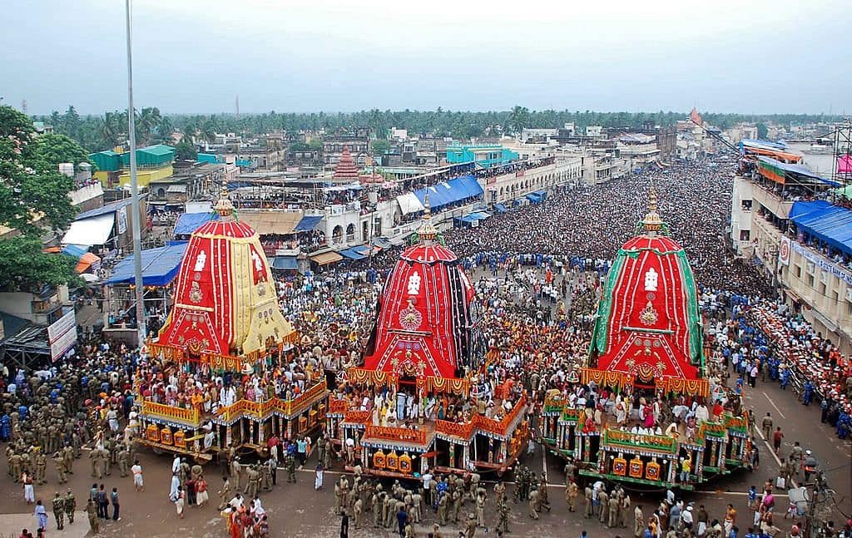

Itinerary…

Day 1: 16 July (Thu) Arrival Bhubaneswar – Konark – Puri
Pickup from Bhubaneswar airport Proceed to the Puri. En-route visit ​​Dhauli (the peace pagoda), Lingaraj Temple, Chausath (64) Yogini temple then drive to Konark on marine drive, visit ​​Chandrabhaga beach & ​​Ramchandi temple. Then visit the famous Sun Temple called black Pagoda, The 12th century temple richly decorated with stone carving. In the evening enjoy light & sound show in Konark (by own cost). ​ After reaching Puri check into the hotel in the evening and enjoy at Puri beach. Overnight at Puri.

Day 2: 17 July (Fri) Puri (Rath Yatra)

Today full day enjoy Rath yatra in Puri. Our representative pickup from hotel, then proceed to witness one of the grandest religious spectacles on the planet.
Rath Yatra celebrates the Hindu belief that Lord Jagannath takes a yearly break in midsummer to retire to his Aunt’s house along with his sister Subhadara and elder brother Balabhadra. All three deities are brought back to the main street in Puri and loaded in their grand chariots and then the great procession proceeds towards Gundicha Temple where the lord enjoy vacation at his aunt’s house.

Day 3: 18 July (Sat) Puri - Chilika Lake (Satpada) – Bhubaneswar

After morning breakfast, check out, Depart for ​​Satapada, Chilka. ​ en- route visit Alarnath Temple after reaching Chilika lake Take a boat (Direct payment ) meets the Irrawaddy Dolphins in nature and the Hradaya –Sagar Sangam or the sea mouth (the point where the lake meets the sea). Enjoy the day at Chilka Lake (India's biggest inland lake spread over 1,100 square kilometers). Evening return to Puri, In the evening enjoy and relax at golden beach, free time shopping at Puri local market. Overnight at Puri.

Day 4: 19 July (Sun) Bhubaneswar Local & Departure
After breakfast check out, drive to Bhubaneswar, local Bhubaneshwar Rajarani temple, Mukteshwar temple, Parshurameshwaram Temple, Khandagiri, Udaygiri jain caves, visit (If time permit) Nandankanan Zoo (This zoo is famous for variety wild life sanctuary & also famous for white Tiger & Lion Safari (Closed On Monday), Tribal museum (Closed On Monday). Ekamra haat for shooping (If time permits) then​ ​transfer to the airport/railway station to catch the flight/ train for onward Journey with a bag full of memories.

Cost per Pax Including GST & A/c Vehicle on CPAI

Total Pax | Rates With Standard | Rates With 3* Star
Cost With 1 Adults (Single sharing) | 38640 | 44880
Cost With 2 Adults | 19680 | 22800
Cost With 4 Pax | 15100 | 18225
Cost With 6 Pax | 13860 | 17000
Cost with 8 Adults | 12450 | 15580
Cost with 10 Adults | 11850 | 14970
Cost with 12 Adults | 11250 | 14380
Cost per Adults/child with Extra bed | 10500 | 12100
Cost with per child without bed | 6500 | 8000

Budget Hotels | 3* Hotels
Puri: Hotel Koshal | Puri: White Sand / Jamindar Palace
Bhubaneswar: The Saaj /Cozzet Victoria | Bhubaneswar: Ira By Orchid/ Excellency

Vehicle
For 2 to 3 Pax | AC Swift Dezire
For 4 to 5 Pax | AC Innova
For 6 to 12 Pax | 13 Sater AC Tempo Traveler

Note:
1:- Hotels & rates are subject to availability at the time of booking confirmation.
2:- Early check in is subject to availability.

3:- For special Rath Yatra darshan have to charge Rs. 3,000/- per person (we will provide dry snacks and tetra pack juices). Below 5 years kids not allowed.

- Pickup and drop from the hotel will be by e-rickshaw.
- A local assistant will accompany the group for the entire day.
- Panda Ji will assist with Shri Jagannath Ji's Darshan on the Ratha during the Ratha Yatra.
- Jagannath ji temple darshan.

Inclusion
Puri (2N) → Bhubaneswar (1N)
On Arrival Flower Bouquet.
Welcome Snacks Kit in Vehicle on pickup time.
Breakfast at the hotel.
​Welcome Drink.
500ml Water bottle per person per day during sightseeing.
​Accommodation on double sharing basis on base category room.​
All transfers and sightseeing by AC Vehicle.
All toll taxes, parking charges, driver allowances.
Government Service Tax @ 5% (GST) as applicable

Exclusion
Any Air or Rail fare.
Boating charges at Chilika Lake.
No Entry Fees.
No Guide Charges.
Any other meal not mentioned in price includes.
Any expenses of personal nature.

FEEL FREE TO CONTACT ANY FURTHER CLARIFICATIONS.
Thanks & Regards,

Holiday Tours|Honeymoon Tours|Family Tours|Pilgrimage Tours|Wildlife & Eco Tours|School Group|College Group Tours| Medical Tours.

DOMESTIC B2B PACKAGES: Odisha & Madhya Pradesh

​​

