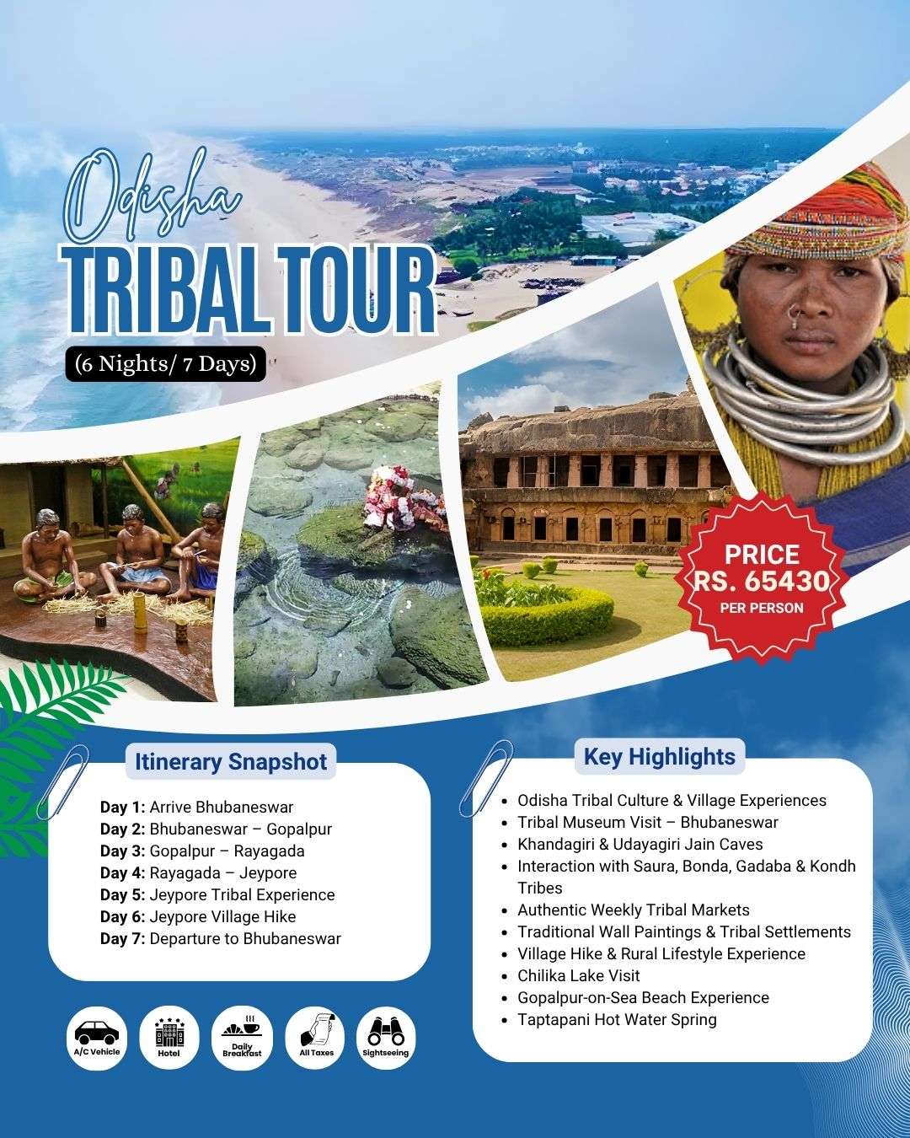

Tribal Tour Odisha

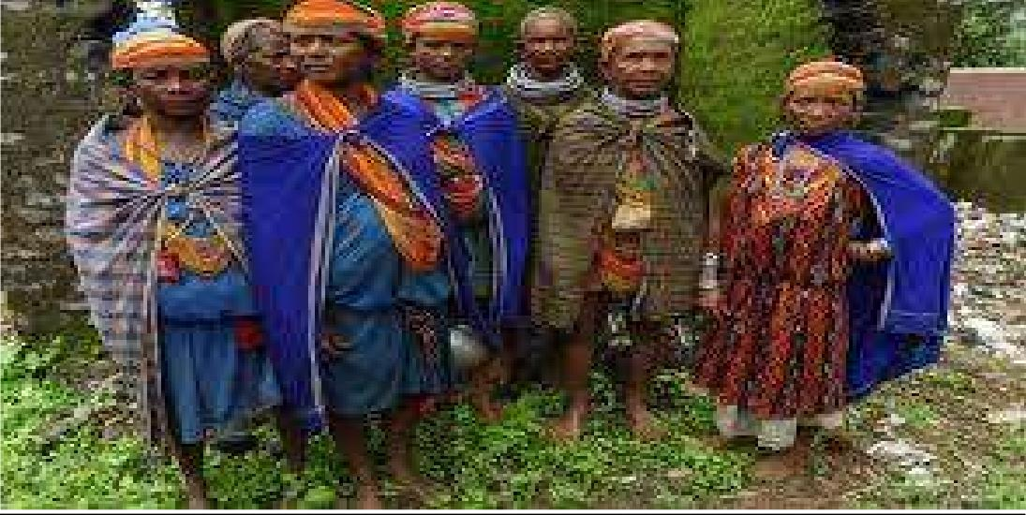

ITINERARY…

DAY 01:- ARRIVE BHUBANESWAR
On the day one of your Odisha tribal tours, you will be arriving at Bhubaneswar airport and driven to the hotel for refreshment. Your first day of the tribal tour in Odisha will begin with exploring the capital city- Bhubaneswar. Visit the the Tribal Museum to get a brief knowledge of the tribes in Odisha and their crafts. And then visit Khandagiri / Udayagiri Jain Caves. If time permits visit Lingaraj Temples, Rajarani Temple & Mukteswar Temple. Evening visit Ekamrahaat for Odisha Art & Handicrafts. Overnight at Bhubaneswar.

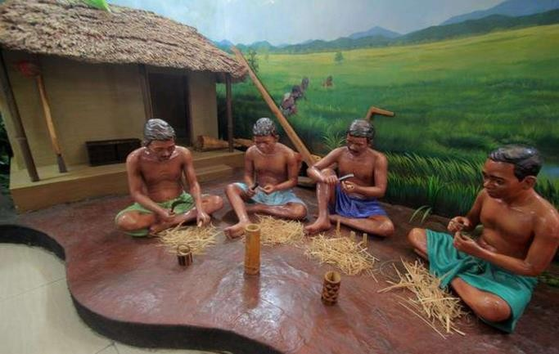

DAY 02:- BHUBANESAR – GOPALPUR
On the second day of your tribal tour in Odisha, Post breakfast, drive to Gopalpur on Sea en-route Chilka Lake. Gopalpur on Sea is a retreat for sea- worshippers. This is the one of the magnificent beaches of Orissa and is worth visiting. Later, visit Chilka Lake ( Barkul), which is divided into an outer channel with a narrow neck. This channel leads into the sea and on the other hand, the main body of the lake has a muddy bottom plentiful in organic matter.
Reach your hotel in Gopalpur on Sea. Check in, freshen up and take a little rest. You may use the rest of the day exploring the nearby lanes, communicating with local people, enjoying street food, etc. Return to your hotel and halt for an overnight stay.

DAY 03:- GOPALPUR- RAYAGADA (TUESDAY)
Morning drive to Rayagada. On the way visit Taptapanithe hot spring & Gunupur region to see the housing of Saura tribes and the famous wall painting.Reached at Hotel & overnight stay in hotel.

DAY 04:- RAYAGADA - JEYPORE
In the morning visit the weekly market of DesiaKondh tribe’s and Dongaria Kondh weekly market – Jaharia Paroja Village- Jeypore. Overnight stay at Jeypore.
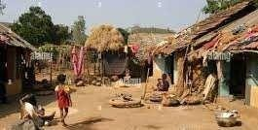

DAY 05:- JEYPORE
Visit weekly market of Bonda, Gadaba & Didai. Later visit of Gadaba Village. morning visit to the most interesting Bonda tribal market at Onukadeli where they come all the way to sale their home made country alcohol .In this market you will also meet interesting Godoba, Paraja, Dedehi and Mali tribes who come to this market to buy their weekly needs or to share a drink from the palm tree.Back to Hotel & Overnight.

DAY 06: JEYPORE: VILLAGE HIKE (DESIA)
In the morning hike for half a day to visit nearby Godaba, Paraja, Mali villages and back to the camp to relax. In the evening enjoy the Dhemsa dance by the host

community and you may join to match your steps with the tunes of the local drum and flute.
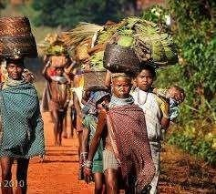

DAY 07:- DEPARTURE TO BHUBANESWAR

The last day of your Odisha tribal tours in the morning depart for Gupteswar region and hike by the riverside to visit Dhurubatribes .In the afternoon visit the weekly market at Baligaon and then board the train at Koraput for Bhubaneswar. Or Else Back to Bhubaneswar by Vehicle.

Validity from 1st April 2026 to till 30th September 2026
Cost Per Pax in Indian Rupees Including GST

Total Pax | Rates With Deluxe Hotel | Rates With Luxury Hotel
Cost With 2 Pax | 65430 | 72100
Cost With 4Pax | 47430 | 54075
Cost with 6 pax | 38390 | 45040
Cost with 8 Pax | 33880 | 40560
Cost per adult with Extra Bed/Mattress | 14940 | 20460

Deluxe Hotel | Luxury Hotel
Bhubaneswar : Ira By Orchid/Excellency or similar Gopalpur: The Park By Zone or similar  Rayagada: Deluxe hotel with basic facility  Jeypore: Deluxe hotel with basic  facility | Bhubaneswar : Swosti Premium / Lyfe or similar  Gopalpur: The Park By Zone or similar Rayagada: Deluxe hotel with basic facility  Jeypore: Deluxe hotel with basic facility

Vehicle:
For 2 to 3 Pax AC Innova
For 4 to 6 Pax AC 13 Seater Tempo Traveler For 6 to 8 Pax 13 Sater AC Tempo Traveler

1:- Hotels & rates are subject to availability at the time of booking confirmation. 2:- Early check in is subject to availability.

Please note: These rates are not valid during Durga Puja & Holi, Ratha Yatra, New Year time, Christmas time, Independence & Republic day, Medical or otherConference time.

Inclusion
Bhubaneswar (1N) → Gopalpur (1N) → Rayagada (1N) → Jeypore (3N)
On Arrival Flower Bouquet.
Guide Service (Hindi & English speaking only)
Welcome Drink.
Welcome Snacks Kit in Vehicle on pickup time. Buffet/fixed menu Breakfast & Dinner at the hotel. Daily 500ml water bottle in Vehicle during sightseeing.
Accommodation on double sharing basis on base category room.
All transfers and sightseeing by AC Vehicle.
All toll taxes, parking charges, driver allowances. Government Service Tax @ 5% (GST) as applicable

Exclusion
Any Air or Rail fare. Boating charges.
No Entry Fees.
Any other meal not mentioned in price includes. Any expenses of personal nature.
Panda arrangements in the Jagannath temple in Puri (As per your requirement).

