

The Green Triangle
4 Nights/ 5 Days - The Essence of Kerala

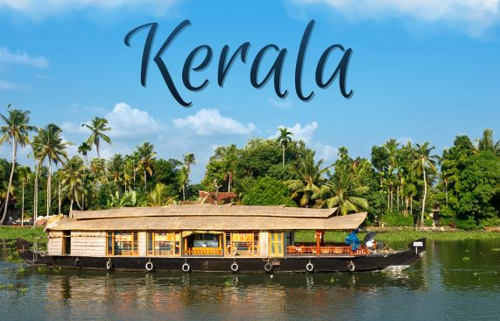

DAY 1: ARRIVE COCHIN; TRANSFER TO MUNNAR

On arrival at Cochin Airport/railway station you will be met and later transferred to Munnar . **Munnar** is a hill station located in the Idukki district of Kerala. Situated at an altitude of 5,200 feet, This traditional beautiful town is popular for its tea estates. Munnar is popular among nature lovers, wildlife enthusiasts, honeymooners, adventure enthusiasts and almost every kind of traveller. >Enroute view Cheeyappara & Valara waterfalls ,On arrival at Munnar, check into Hotel and relax for the rest of the day. **Overnight stay at Munnar**"

DAY 2: MUNNAR
Munnar is situated at the confluence of three mountain streams - Mudrapuzha, Nallathanni and Kundale, Munnar is 1600 Meter above sea level. This majestic hill station was once the summer resort of the British government in South India. Sightseeing in Munnar - Mattupetty Dam, Kundale Lake, Echo point, Rajamalai where you can visit the rarest species known as Nilgiri Thars ( Subject to opening)

DAY 3: MUNNAR – THEKKADY
After Breakfast from Hotel/Resort, Check out and drive to Thekkady. A scenic journey past mist capped mountains, spice plantations and open grasslands lined with spectacular water falls & delightful trekking trails form the access to your hide way here. On arrival Check in to your already booked hotel in Thekkady,
Refresh and Proceed to Thekkady Sightseeing . boat safari on the Periyar Lake extends a lifetime’s chance to spot exotic wildlife in its natural habitat. Overnight at Thekkady (Extra Payable)
Note: Boat Ride at Lake Periyar, please book direct by online in advance: https://www.periyartigerreserve.org

DAY 04: THEKKADY – ALLEPPEY
After Breakfast, Checkout from Hotel/Resort, and drive to Alleppey, Check in to your already booked hotel in Alleppey, Alleppey is one of the most popular cities in Kerala which is known for its azure backwaters and houseboat cruises., You may have the chances to take part in activities like:
Option of Doing Boating at Vembanad Lake at Alleppey (Direct Payable), Evening Visit Alappuzha Beach The beaches of Alappuzha offer excellent sunset views. Evening Back to Resort, Overnight stay at Alleppey
DAY 06: COCHIN AIRPORT DROP
After check out from the Hotel and drive to Cochin Airport / railway station (depend on your departure place) for your flight / train back home, feeling contented about a wonderful holiday you spent in the God's Own Country.

PACKAGE DETAILS:

Program | Meal Plan | 3 Star Hotels and Resorts | 4 Star Hotels and Resorts | 5 Star Hotels and Resorts
Cochin to Munnar | CPAI | Arbour Resort or Similar | Southern panorama or Similar | Fogg Resort or Similar
At Munnar | CPAI | Arbour Resort or Similar | Southern Panorama or Similar | Fogg Resort or Similar
Munnar to Thekkady | CPAI | Jungle Park or Similar | Holiday vista or Similar | Serene Horizen or Similar
Thekkady to Alleppey | CPAI | Venice Iva Residency or Similar | PMC Lakeshore or Similar | Ramada by Wyndham or Similar
Alleppey to Cochin drop

Pax | Cab | Special rate 3 Star | Special rate 4 star | Special rate 5 star
For 2 Pax | Sedan | 12500 Per Person | 14500 Per Person | 19000 Per Person
For 4 pax | Innova | 10500 per person | 12550 per person | 1750 per person
For 6 pax | Traveller | 10200 per person | 12250 per person | 16750 per person
For 8 pax | Traveller | 9350 per person | 11400 per person | 15900 per person
Extra Bed Adult |  | 4500 per bed | 5650 per bed | 7100 per bed
Child With Bed |  | 3350 Per Child | 4300 Per Child | 5100 Per Child
Child Without Bed |  | 2200 Per Child without bed | 2250 Per Child without bed | 3200 Per Child without bed
Dinner Supplement |  | 2550 Per person | 3200 Per person | 4000 per person

Validity: 01 October 2025 – 31 March 2026
Above rates are not valid from 17 October 2025-to 30 October 2025 & 20 December 2025 to 5 January 2026

COST INCLUDES
- Accommodation in the above-mentioned hotels or similar in base category rooms
- Breakfast included in all hotels
- Transportation Service using AC Sedan Car, AC Innova , Ac Traveler respectively
- Transport Cost inclusive of Driver Bata, Night Halt, and Parking & Toll.
- Standard Service time of the Driver and Vehicle will be from 08 AM to 07 PM.

COST EXCLUDES
- Flight & Rail tickets
- Lunch and /or beverages, other than those mentioned in the inclusions
- Assistance service on arrival / departure / hotels.
- Monument & Sightseeing Entrance Fee anywhere
- Camera Charges, Activity Fees & all other expenses which are in personal nature.
- Guide, Tour Escort (Can be provided up on request with extra Charges).
- Boat Ride, Joy Ride, Plantation visits, Trekking Etc.
- Early Check in/ Late Checkout & Any Extra Meals.
- Any other item not specified in cost inclusions

******************

