NORTH Kerala –Kannur Package

2Nights/ 3 Days

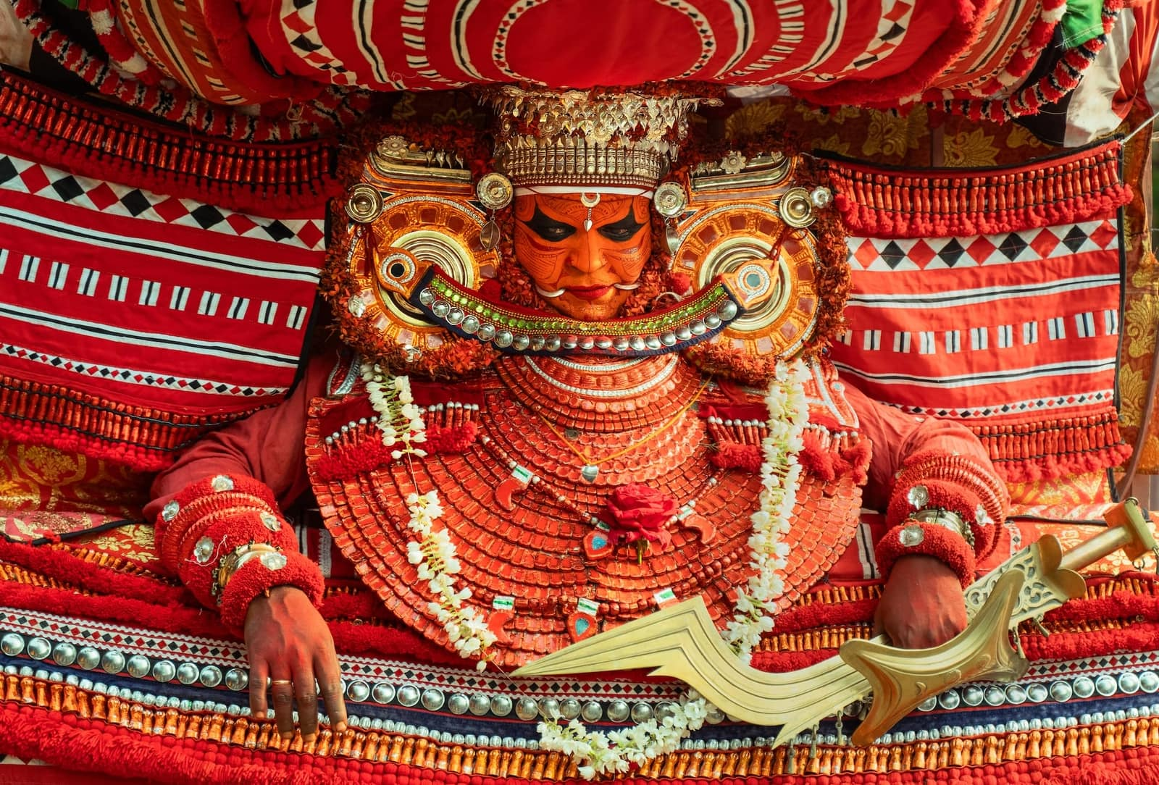

Day 01 – Arrival Kannur & Local Sightseeing
- Arrival at Kannur Airport / Railway Station.
- Transfer to hotel and check-in.
- Visit St. Angelo Fort
- Visit Payyambalam Beach
- Visit Muzhappilangad Drive-in Beach.
- Evening visit to Parassinikadavu Sree Muthappan Temple and experience the traditional Muthappan ritual/Theyyam, subject to the day's performance schedule.
- Return to hotel.
- Overnight stay in Kannur.

Day 02 – Theyyam Experience & Kannur Sightseeing
- Early morning breakfast.
- Proceed to a local Kavu/temple where Theyyam is scheduled.
- Witness the traditional Theyyam performance, including elaborate costumes, make-up, ritual music and dance.
- The exact temple will be selected according to the live Theyyam calendar and performance timings for the travel date. Kerala Tourism maintains a calendar of Theyyam festivals with temple locations and approximate dates.
- Later visit:
  - Aralam / local cultural attractions depending on timing
  - Kannur Handloom Centre
  - Local market
- Evening leisure / optional second Theyyam performance if available.
- Overnight stay in Kannur.

Day 03 – Theyyam / Temple Visit & Departure
- Breakfast and check-out.
- If a morning Theyyam is available, attend the performance.
- Visit Parassinikadavu Muthappan Temple or another nearby temple/Kavu.
- Proceed for departure to Kannur Airport / Railway Station.

Tour ends!!!!

PACKAGE DETAILS:

Destination | Meal Plan | 3 Star Hotels and Resorts | 4 Star Hotels and Resorts
Kannur | CPAI | Malabar Residency or Similar | Benale International  or Similar

Pax | Cab | Special rate 3 Star | Special rate 4 star
For 2 Pax | Sedan | 12,500/- Per Person | 13,000 Per Person
For 4 pax | Ertiga | 8,600 per person | 9,200/-per person
For 6 pax | crysta | 7,800/- per person | 8,300/- per person
Extra Bed Adult |  | 2100 per bed | 2,200 per bed
Child With Bed |  | 1800 Per Child | 1,900 Per Child
Child Without Bed |  | 1200 Per Child without bed | 1,250 Per Child without bed

Validity: 01st August 26 – 31st March 27 (Not Valid on Peak dates like Pooja, Diwali, Pongal & Christmas Newyear dates & Other blackout dates)
COST INCLUDES
- Accommodation in the above-mentioned hotels or similar in base category rooms
- Breakfast included in all hotels
- Transportation Service using AC Sedan Car, AC Ertiga, Ac Crysta respectively.
- Transport Cost inclusive of Driver Bata, Night Halt, and Parking & Toll.
- Standard Service time of the Driver and Vehicle will be from 08 AM to 07 PM.
COST EXCLUDES
- Flight & Rail tickets
- Lunch and /or beverages, other than those mentioned in the inclusions
- Assistance service on arrival / departure / hotels.
- Monument & Sightseeing Entrance Fee anywhere
- Camera Charges, Activity Fees & all other expenses which are in personal nature.
- Guide, Tour Escort (Can be provided up on request with extra Charges).
- Boat Ride, Joy Ride, Plantation visits, Trekking Etc.
- Early Check in/ Late Checkout & Any Extra Meals.
- Any other item not specified in cost inclusions
Terms and Conditions
Hotels
- Hotels are not categorized by government authorities; instead, they are classified based on the facilities they provide.
- The standard check-in time is 2:00 PM, and the check-out time is 10:30 AM.

Hill Station Resorts
- Resorts in Munnar, Thekkady, Coorg, Wayanad, etc. do not have A/C rooms in 3-star category hotels/resorts. However, A/C can be provided at an additional cost upon request.
- Resorts in Ooty and Kodaikanal generally do not have A/C rooms (though some hotels do).

Houseboats
- Houseboats are not like hotels; their classification is based on A/C timing and available facilities.
- Houseboat rooms differ from hotel/resort rooms.
- Check-in time: 12 PM | Check-out time: 9 AM.
- Houseboats do not cruise after 5 PM and will dock near the mainland.
- Electricity fluctuations may occur due to weather conditions.

Houseboat Day Cruise
- Available from 12 PM to 5 PM only.
- A/C is available only in the Luxury category.
- In the Premium category, A/C is available only in rooms.
- Lunch, evening tea/coffee, and snacks will be served onboard.

Sightseeing & Entrance Fees
- Activity and entrance charges at sightseeing locations are not included in the package.

Vehicles
- The Innova provided is not a Crysta; it is a standard Innova.
- If a Crysta is required, it must be specified, and the rates will be different.
New Innova models are unavailable as production has stopped.

Child Policy
- Child Below 5 years complimentary.
- Child 5 -10 years. without extra bed as mention in cost column (CNB = Child no Bed)
- Child 5 -10 years. with extra bed as mention in cost column (CWB = Child with Bed)
- Above 10 years / Extra adult with an extra bed sharing room are same.
- Hotels are very strict with the child policy. Please carry the age proof so that it can be produced
if asked by hotel.

Booking / Payment Policy:
- Journey date within 60 days 20% of package cost.
- Journey date within 30 days 50% of package cost.
- Journey Date within 30 - 20 days 75% of package cost.
- Journey Date within 19 -10 days 100% of package cost / balance full package cost.

Cancellation Policy
- More than 60 days Full refund (after deducting minimum charges per person as service fee)
- 30-60 days 35 % of Package Cost, charge is applicable as per cancellation policy.
- 15-29 days 50% of Package Cost, charge is applicable as per cancellation policy.
- 7-14 days 70% of Package Cost, charge is applicable as per cancellation policy.
- Less than 7 days of your travel date if you cancel your trip then 100% of the package cost, charge is applicable as per cancellation policy. (There is no refund even if no show)

******************

