KERALA HONEYMOON BLISS
5 NIGHTS/ 6 DAYS

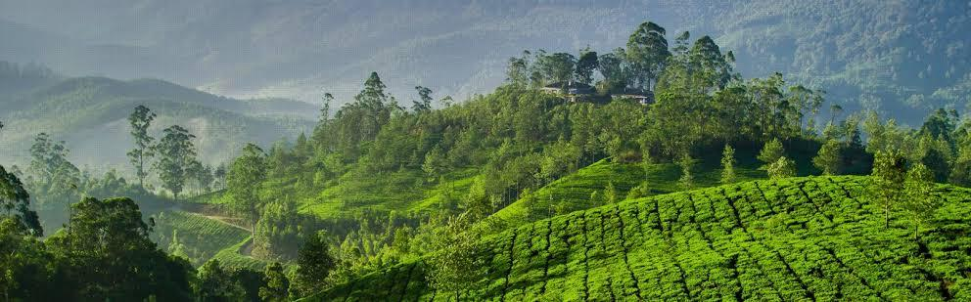

DAY 1: ARRIVE COCHIN; TRANSFER TO MUNNAR

On arrival at Cochin Airport/railway station you will be met and later transferred to Munnar . **Munnar** is a hill station located in the Idukki district of Kerala. Situated at an altitude of 5,200 feet, This traditional beautiful town is popular for its tea estates. Munnar is popular among nature lovers, wildlife enthusiasts, honeymooners, adventure enthusiasts and almost every kind of traveller. >Enroute view Cheeyappara & Valara water falls, On arrival at Munnar, check into Hotel and relax for the rest of the day. **Overnight stay at Munnar**"

DAY 2: MUNNAR
Munnar is situated at the confluence of three mountain streams - Mudrapuzha, Nallathanni and Kundale, Munnar is 1600 Meter above sea level. This majestic hill station was once the summer resort of the British government in South India. Sightseeing in Munnar - Mattupetty Dam, Kundale Lake, Echo point, Rajamalai where you can visit the rarest species known as Nilgiri Thars (Subject to opening)

DAY 3: MUNNAR – THEKKADY
After breakfast checkout from hotel and drive to Thekkady, on arrival check in to the hotel. Proceed for Spice plantation tour. Later in the evening, proceed for Boating in Lake Periyar (part of conducted tour) (Extra Payable). Back to the hotel for overnight stay.

DAY 4: THEKKADY
After breakfast from Hotel/Resort, Ready for second day sightseeing at **Thekkady**. Today being the day to explore more in Thekkady. Some of the sightseeing points / activities are as listed below: >**Spice Garden Visit, Elephant Ride, Jeep safari (Optional Cost), Shopping at Spice Shop in Thekkady.** >Evening Back To Resort Overnight stay at Thekkady. Note: Boat Ride at Lake Periyar, please book direct by online in advance: https://www.periyartigerreserve.org to avoid rush

DAY 05: THEKKADY – ALLEPPEY
After Breakfast, Checkout from Hotel/Resort, and drive to Alleppey, Check in to your already booked hotel in Alleppey, Alleppey is one of the most popular cities in Kerala which is known for its azure backwaters and houseboat cruises., You may have the chances to take part in activities like:
Option of Doing Boating at Vembanad Lake at Alleppey (Direct Payable), Evening Visit Alappuzha Beach The beaches of Alappuzha offer excellent sunset views. Evening Back to Resort, Overnight stay at Alleppey
DAY 06: KOCHI AIRPORT DROP
After check out from the Hotel and drive to Cochin Airport / railway station (depend on your departure place) for your flight / train back home, feeling contented about a wonderful holiday you spent in the God's Own Country.
💕 Honeymoon Special Inclusions
🕯️ 1 Night – Romantic Candle Light Dinner
Enjoy a beautifully decorated private dinner setup with candles, flowers and a romantic ambiance. @ Munnar
🌹 1 Night – Special Flower Bed Decoration
Romantic room decoration with fresh flowers and beautiful floral arrangements for a memorable honeymoon night. @ Munnar
📸 1 Day – Drone Photo Shoot @ Munnar
Capture your special honeymoon moments with a professional drone photo shoot, featuring stunning aerial views of you and the beautiful Kerala landscape.

PACKAGE DETAILS:

Program | Meal Plan | 3 Star Hotels and Resorts | 4 Star Hotels and Resorts | 5 Star Hotels and Resorts
Cochin to Munnar | CPAI | Arbour Resort or Similar | Southern panorama or Similar | Leaf Resort or Similar
At Munnar | CPAI | Arbour Resort or Similar | Southern Panorama or Similar | Leaf Resort or Similar
Munnar to Thekkady | CPAI | Tiger Trail or Similar | Spice Grove or Similar | Serene Horizen or Similar
Thekkady | CPAI | Tiger Trail or Similar | Spice Grove or Similar | Serene Horizen or Similar
Thekkady to Alleppey | CPAI | Venice Iva Residency or Similar | Paloma or Similar | Ramada by Wyndham or Similar
Alleppey to Cochin drop

Pax | Cab | Special rate 3 Star | Special rate 4 star | Special rate 5 star
For 2 Pax | Sedan | 22,400/- Per Person | 24,800/-Per Person | 32,400/- Per Person

Validity: 01st October 26 – 31st March 27 (Not Valid on Peak dates like Pooja, Diwali , Pongal & Christmas Newyear dates)
COST INCLUDES
- Accommodation in the above-mentioned hotels or similar in base category rooms
- Breakfast included in all hotels
- Transportation Service using AC Sedan Car, AC Ertiga, Ac Traveler respectively.
- Transport Cost inclusive of Driver Bata, Night Halt, and Parking & Toll.
- Standard Service time of the Driver and Vehicle will be from 08 AM to 07 PM.
COST EXCLUDES
- Flight & Rail tickets
- Lunch and /or beverages, other than those mentioned in the inclusions
- Assistance service on arrival / departure / hotels.
- Monument & Sightseeing Entrance Fee anywhere
- Camera Charges, Activity Fees & all other expenses which are in personal nature.
- Guide, Tour Escort (Can be provided up on request with extra Charges).
- Boat Ride, Joy Ride, Plantation visits, Trekking Etc.
- Early Check in/ Late Checkout & Any Extra Meals.
- Any other item not specified in cost inclusions
Terms and Conditions
Hotels
- Hotels are not categorized by government authorities; instead, they are classified based on the facilities they provide.
- The standard check-in time is 2:00 PM, and the check-out time is 10:30 AM.

Hill Station Resorts
- Resorts in Munnar, Thekkady, Coorg, Wayanad, etc. do not have A/C rooms in 3-star category hotels/resorts. However, A/C can be provided at an additional cost upon request.
- Resorts in Ooty and Kodaikanal generally do not have A/C rooms (though some hotels do).

Houseboats
- Houseboats are not like hotels; their classification is based on A/C timing and available facilities.
- Houseboat rooms differ from hotel/resort rooms.
- Check-in time: 12 PM | Check-out time: 9 AM.
- Houseboats do not cruise after 5 PM and will dock near the mainland.
- Electricity fluctuations may occur due to weather conditions.

Houseboat Day Cruise
- Available from 12 PM to 5 PM only.
- A/C is available only in the Luxury category.
- In the Premium category, A/C is available only in rooms.
- Lunch, evening tea/coffee, and snacks will be served onboard.

Sightseeing & Entrance Fees
- Activity and entrance charges at sightseeing locations are not included in the package.

Vehicles
- The Innova provided is not a Crysta; it is a standard Innova.
- If a Crysta is required, it must be specified, and the rates will be different.
New Innova models are unavailable as production has stopped.

******************

