The Green Triangle
4 Nights/ 5 Days - The Essence of Kerala

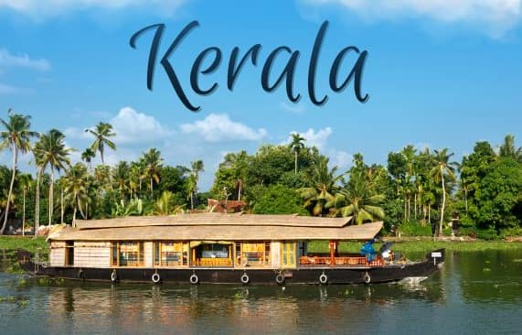

DAY 1: ARRIVE COCHIN; TRANSFER TO MUNNAR

On arrival at Cochin Airport/railway station you will be met and later transferred to Munnar . **Munnar** is a hill station located in the Idukki district of Kerala. Situated at an altitude of 5,200 feet, This traditional beautiful town is popular for its tea estates. Munnar is popular among nature lovers, wildlife enthusiasts, honeymooners, adventure enthusiasts and almost every kind of traveller. >Enroute view Cheeyappara & Valara waterfalls ,On arrival at Munnar, check into Hotel and relax for the rest of the day. **Overnight stay at Munnar**"

DAY 2: MUNNAR
Munnar is situated at the confluence of three mountain streams - Mudrapuzha, Nallathanni and Kundale, Munnar is 1600 Meter above sea level. This majestic hill station was once the summer resort of the British government in South India. Sightseeing in Munnar - Mattupetty Dam, Kundale Lake, Echo point, Rajamalai where you can visit the rarest species known as Nilgiri Thars ( Subject to opening)

DAY 3: MUNNAR – THEKKADY
After Breakfast from Hotel/Resort, Check out and drive to Thekkady. A scenic journey past mist capped mountains, spice plantations and open grasslands lined with spectacular water falls & delightful trekking trails form the access to your hide way here. On arrival Check in to your already booked hotel in Thekkady,
Refresh and Proceed to Thekkady Sightseeing . boat safari on the Periyar Lake extends a lifetime’s chance to spot exotic wildlife in its natural habitat. Overnight at Thekkady (Extra Payable)
Note: Boat Ride at Lake Periyar, please book direct by online in advance: https://www.periyartigerreserve.org

DAY 04: THEKKADY – ALLEPPEY
After Breakfast, Checkout from Hotel/Resort, and drive to Alleppey, Check in to your already booked hotel in Alleppey, Alleppey is one of the most popular cities in Kerala which is known for its azure backwaters and houseboat cruises., You may have the chances to take part in activities like:
Option of Doing Boating at Vembanad Lake at Alleppey (Direct Payable), Evening Visit Alappuzha Beach The beaches of Alappuzha offer excellent sunset views. Evening Back to Resort, Overnight stay at Alleppey
DAY 06: COCHIN AIRPORT DROP
After check out from the Hotel and drive to Cochin Airport / railway station (depend on your departure place) for your flight / train back home, feeling contented about a wonderful holiday you spent in the God's Own Country.

PACKAGE DETAILS:

Program | Meal Plan | 3 Star Hotels and Resorts | 4 Star Hotels and Resorts | 5 Star Hotels and Resorts
Cochin to Munnar | CPAI | Arbour Resort or Similar | Southern panorama or Similar | Leaf Resort or Similar
At Munnar | CPAI | Arbour Resort or Similar | Southern Panorama or Similar | Leaf Resort or Similar
Munnar to Thekkady | CPAI | Tiger Trail or Similar | Spice Grove or Similar | Serene Horizen or Similar
Thekkady to Alleppey | CPAI | Venice Iva residency or Similar | Paloma or Similar | Ramada by Wyndham or Similar
Alleppey to Cochin drop

Pax | Cab | Special rate 3 Star | Special rate 4 star | Special rate 5 star
For 2 Pax | Sedan | 16,100/-Per Person | 18,200/- Per Person | 23,500/- Per Person
For 4 pax | Innova | 12,500/-per person | 14,500/-/- per person | 19,800/- per person
For 6 pax | Traveller | 13,000/- per person | 15,100/-per person | 20,300/-per person
For 8 pax | Traveller | 11,700/- per person | 13,800/- per person | 19,200/- per person
Extra Bed Adult |  | 4500 per bed | 5750 per bed | 7800 per bed
Child With Bed |  | 3500 Per Child | 4300 Per Child | 6300 Per Child
Child Without Bed |  | 2300 Per Child without bed | 2600 Per Child without bed | 3800 Per Child without bed
Dinner Supplement |  | 2800 Per person | 3300 Per person | 4200 per person

Validity: 01st October 2026 – 31st March 27 (Not Valid on Peak dates like Pooja, Diwali , Pongal & Christmas Newyear dates)
COST INCLUDES
- Accommodation in the above-mentioned hotels or similar in base category rooms
- Breakfast included in all hotels
- Transportation Service using AC Sedan Car, AC Ertiga, Ac Traveler respectively
- Transport Cost inclusive of Driver Bata, Night Halt, and Parking & Toll.
- Standard Service time of the Driver and Vehicle will be from 08 AM to 07 PM.
COST EXCLUDES
- Flight & Rail tickets
- Lunch and /or beverages, other than those mentioned in the inclusions
- Assistance service on arrival / departure / hotels.
- Monument & Sightseeing Entrance Fee anywhere
- Camera Charges, Activity Fees & all other expenses which are in personal nature.
- Guide, Tour Escort (Can be provided up on request with extra Charges).
- Boat Ride, Joy Ride, Plantation visits, Trekking Etc.
- Early Check in/ Late Checkout & Any Extra Meals.
- Any other item not specified in cost inclusions

******************

