HYDERABAD

Taste the Tradition, Walk the History

2 Nights/ 3 Days

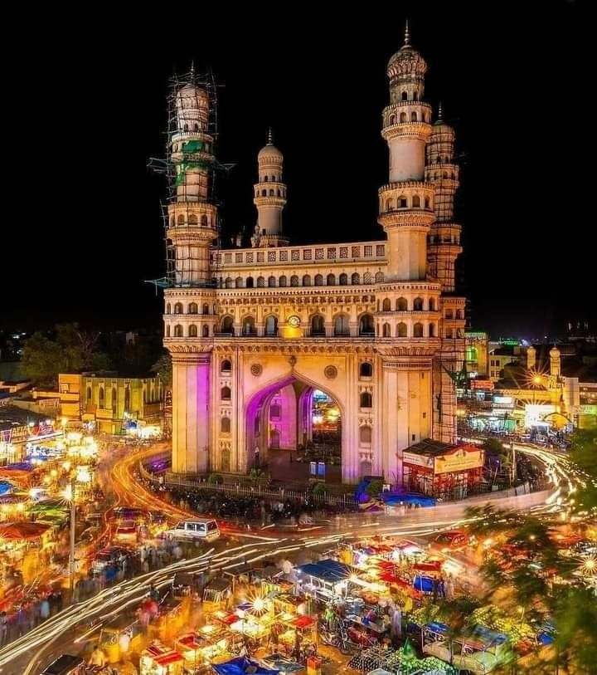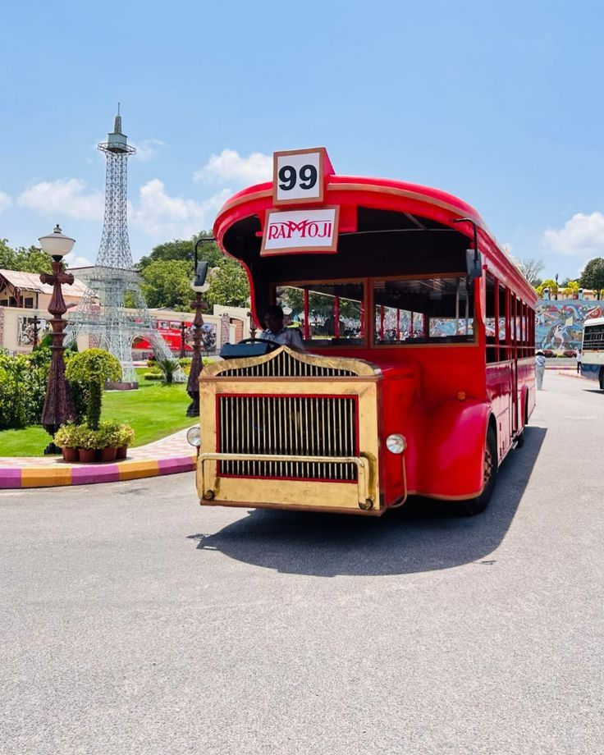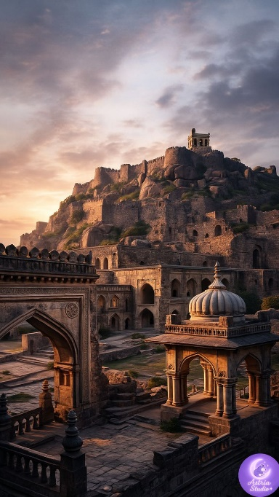

DAY 1: A Gentle Introduction to Hyderabad
On arrival at Hyderabad Airport, you will be warmly received and transferred to your hotel for check-in and relaxation. As the city unfolds, begin your journey with a peaceful visit to Birla Mandir, offering calm views and spiritual serenity. Continue to the majestic Qutub Shahi Tombs, where royal stories rest in timeless stone, followed by an exploration of the legendary Golconda Fort, echoing with tales of power and grandeur. As evening approaches, enjoy leisure moments at Lumbini Park before gliding across the tranquil waters of Hussain Sagar Lake. Conclude the day with a captivating laser show that brings Hyderabad’s history to life, before returning to the hotel for an overnight stay

DAY 2: Ramoji Film City – A Day Inside the World of Cinema
Step into the magical world of movies with a full-day holiday studio tour at the iconic Ramoji Film City. The experience begins with a thematic opening ceremony at 9:45 a.m., setting the tone for an unforgettable journey into cinema. Travel through the vast studios aboard a charming non-AC vintage bus as you explore famous film locations, including the grand Baahubali sets. Enjoy the excitement of Ramoji Movie Magic with thrilling experiences such as the Action Theatre, Space Yatra, and Filmi Duniya, where fantasy and filmmaking come alive. Be entertained by spectacular live shows including Spirit of Ramoji, the Wild West Stunt Show, Dad jinn’s Live TV Show, and Lights, Camera, Action. Wander through beautifully designed locations and lush gardens before enjoying a delicious vegetarian lunch at Eureka. The fun continues at Fundustan, featuring Borasura, Toyland, and an energetic Rain Dance, making it a delight for children and families alike. Discover nature during the eco tour, visiting the Butterfly Park, Exotic Bird Park – Wings, and the serene Bonsai Garden – Vaman. Conclude the day with a fascinating motion-capture virtual shoot experience, offering a glimpse into modern filmmaking technology.
Note: Professional photography is not permitted. Cameras beyond DSLR specifications (18–55 mm) and any form of recording instruments are strictly prohibited

DAY 3: Echoes of Faith, Art, and Farewell
The day begins with a visit to the regal Chow Mahalla Palace, once the seat of the Nizams and a symbol of royal elegance. Continue to the iconic Charminar, the heart of Hyderabad, standing tall amid centuries of history, followed by a peaceful visit to the sacred Mecca Masjid nearby. Step into the world of art and heritage at the Salarjung Museum, home to one of the finest collections of rare artefacts and timeless treasures. Later, stroll through the lively lanes of Laad Bazaar, famous for its traditional bangles and local crafts. As the journey nears its end, seek serenity at the Statue of Equality, a symbol of harmony and devotion. With memories of Hyderabad etched in the heart, proceed for transfer and drop at the airport.
Validity: 01st October 26 – 31st March 27 (Not Valid on Peak dates like Pooja, Diwali, Pongal & Christmas Newyear dates)

PACKAGE DETAILS:
PLACE | HOTEL | MEAL PLAN
Hyderabad | Aditya Hometel | MAP

Pax | Cab | Special rate
For 2 Pax | Sedan | 16,890/- Per Person
For 4 pax | Ertiga | 13,560/- per person
For 6 pax | Innova Crysta | 12,030/- per person

COST INCLUDES
- Double share Accommodation in 3-star premium Hotel
- Sightseeing
- Ramoji film city entry Ticket with Veg / Non-Veg-Lunch
- Daily Buffet breakfast and dinner at hotel
- Airport meet & greet, pick-up and drop
- English/ Hindi speaking driver with Sedan, Ertiga or Innova Crysta throughout the trip
- Applicable Taxes
COST EXCLUDES
- Flight & Rail tickets
- Lunch and /or beverages, other than those mentioned in the inclusions
- Monument & Sightseeing Entrance Fee anywhere
- Camera Charges, Activity Fees & all other expenses which are in personal nature.
- Guide, Tour Escort (Can be provided up on request with extra Charges).
- Early Check in/ Late Checkout & Any Extra Meals.
- Any other item not specified in cost inclusions

Terms and Conditions

Terms & Conditions
Booking
Reservation Policy:
Reservation could be made through mail, fax or phone clearly stating the services required. We take the undertaking process of these reservations and duly confirm the arrangements.
Hotel Timings
- Check-in Time: 12.00 PM
- Check-out time: 11.00 AM
Payment terms:
For the services contracted, 50% of total tour cost on booking to hold the booking on a confirmed basis and the balance amount should be paid before 30 Days of commencement of your tour. We hold the right to decide upon the amount to be paid as an advance payment, based on the nature of services and the time left for the commencement of the services. Apart from the above in some cases like International Tours, Flight Tickets, Visa, Special train journeys like Palace on Wheels, hotel or resort bookings during the high peak tourist season (X-Mas, New Year) full payment is required to be sent in advance.
Payment Options:
Payment can be made by Credit Card through our secured online payment gateway system, by Bank Transfer, Cash payment to our offices in your city or by Demand Draft / Cheque. All payments should be free and clear of any withholding tax and deduction. Bank charges, if any, for
Rights to amend the itinerary if required
Tour once commenced will strictly go as per the itinerary finalized. In case of events and circumstances beyond our control, we reserve the right to change all or parts of the contents of the itinerary for safety and wellbeing of our esteemed passengers.
Policy Regarding Cancellation / No Show / Early Departure
In case of cancellation of tour/travel services due to any avoidable/unavoidable reason/s we must be informed in writing. Cancellation charges would be effective from the date we receive letter in writing and cancellation charges would be as follows:

Period of Cancellation | Cancellation Charges
15 Days before departure | 50% of the Tour Cost
7 Days before Departure | 75% of the Tour Cost
Less than 7 Days before departure | 100% of the Tour Cost

Please note - Irrespective of above-mentioned cancellations slabs - in case of cancellation of tour services after the booking is made with us - a minimum 10% service charges would be applicable.

In case you cancel the trip after commencement refund would be restricted to a limited amount that too would depend on the amount that we would be able to recover from the hoteliers we patronize. For unused hotel accommodation, chartered transportation and missed meals etc. we do not bear any responsibility to refund.
Refund
In regard to refund of unused / unutilized services (which are paid for and cancelled in advance) the refund amount would be worked out on the basis of cancellation policy as described above and the money would be accordingly refunded to the person who has made the payment to us. Please note that the refund process may take 2 - 4 weeks due to banking procedures. If the refund is made to the credit card account OR to Bank account, the bank charges would be debited from the refund amount.
Our Liabilities & Limitations:
Please note that after the finalization of the tour/service cost, if there are any hikes in entrance fees of monuments/museums, taxes, fuel cost or guide charges by the Govt. of India, the same would be charged as extra.
All itineraries are sample itineraries, intended to give you a general idea of the likely trip schedule. Numerous factors such as weather, road conditions, the physical ability of the participants etc. may dictate itinerary changes either before the tour or while on the trail. We reserve the right to change any schedule in the interest of the trip participants' safety, comfort & general wellbeing.
Our rates are based on the prevailing rates as negotiated by us with the hotels, airlines etc. Hotels and Airlines retain the right to modify the rates without notice. In case of such changes the rates quoted before the modification, can be changed by us according to the modifications by hotels or airlines. All hotel bookings are based on usual check in and checkout time of the hotels until unless indicated in the itinerary.
We shall not be responsible for any delays & alterations in the programmed or expenses incurred - directly or indirectly - due to natural hazards, flight cancellations, accident, breakdown of machinery or equipment’s, breakdown of transport, weather, sickness, landslides, political closures or any untoward incidents.

We shall not be responsible for any loss, injury or damage to person, property, or otherwise in connection with any accommodation, transportation or other services, resulting - directly or indirectly - from any act of GOD, dangers, fire, accident, breakdown in machinery or equipment, breakdown of transport, wars, civil disturbances, strikes, riots, thefts, pilferages, epidemics, medical or custom department regulations, defaults, or any other causes beyond our control.
We do not have any insurance policy covering the expenses for accident, sickness, loss due to theft, or any other reasons. Visitors are advised to seek such insurance arrangements in their home country. All baggage & personal property/s at all times are at the client's risk.
Passports & Visas
To travel to India from overseas countries except for the citizen of Nepal & Bhutan, one needs a 06 months valid passport and a valid Visa. And processing of Passport and Visa are not included in the tour cost.
General Terms & Conditions
- The company reserves the right to postpone or cancel any of the tours advertised, without assigning any reason. In that case, money paid by the tour participant will be fully refunded but no compensation claim will be entertained.
- Due to certain unavoidable circumstances, the Company reserves the right to change / modify / vary and alter the tour itinerary if it becomes necessary. In such changes, compensations or claiming of refunds by the guests will not be entertained by the Company for limitation and also for the non- availability of certain services with entry tickets, restaurants, sightseeing shopping etc. even though included in tour itinerary.
- For Single passenger, without family, you will share a room either on twin or triple sharing basis (Roll away bed) depending on the booking. If we do not have a single person like you, then you will have to take the single supplement with an additional cost.
- The tariff of the tour quoted is calculated as per the rates prevailing at the time of quoting it. The Company reserves the right to change the tariff in the event of modification / alteration / change / variation in the said rates before the date of departure.
- Tour cost is based on minimum 30 passengers travelling together in the group. If there is a drastic fall in the number, then the offered meal plan, vehicle and other services may change accordingly.

- Company takes care to select hotels and book the same on behalf of tourists at convenient locations subject to availability. In case of non-availability of rooms in same hotel, Company has the right to split the accommodation in different hotels. Hotel accommodation is generally provided on Twin sharing basis in standard rooms and the third bed is often a roll-away mattress put in a twin-bedded room. Air-conditioning, central heating and other facilities are provided by the hotels depending upon various factors including weather / climatic conditions, local systems, tour type, etc.
- As a Tour Operator, the company does not have any control over Airlines, Coach Companies, Shipping Companies, Hotels, Local Transport or any other facilities, provided by the third parties. The company is not responsible for the delays or deficiencies in the services provided by outside agencies. Also please note that the company does not have any control on schedules of opening and closing timings of the tourist attractions.
- In computerized reservation system of Airlines seats once reserved cannot be changed. Tour participants will have to travel by the same seat provided by Airline.
- Group tour, Single passenger (without family), will have to share a room either on twin or triple sharing basis (Roll away bed) depending on the booking. If we do not have a single person like you, then you will have to take the single supplement with an additional cost.
- Group tours cost is based on minimum 30 passengers travelling together in the group. If there is a drastic fall in the number, then the offered meal plan, vehicle and other services may change accordingly.
- Adult Rate applicable per person on Double / Twin / Triple Sharing Room. Child Rate mentioned in the costing would be applicable only when the Child share the same room with Parents. If separate room required, Adult fare will be levied.
- takes care to select hotels and book the same on behalf of tourists at convenient locations subject to availability. In case of non-availability of rooms in same hotel, Company has the right to split the accommodation in different hotels. Hotel accommodation is generally provided on Twin sharing basis in standard rooms and the third bed is often a roll-away mattress put in a twin bedded room. Air conditioning, central heating and other facilities are provided by the hotels depending upon various factors including weather / climatic conditions, local systems, tour type, etc.
- As a Travel House / Tour Operators, the company does not have any control over Airlines, Railways, Coach Companies, Shipping Companies, Hotels, Local Transport or any other facilities, provided by the third parties. The company is not responsible for the delays or deficiencies in the services provided by outside agencies. Also please note that the company does not have any control on schedules of opening and closing timings of the tourist attractions.
- In computerized reservation system of Indian Railways/Airlines, the berths / seats once reserved cannot be changed. Tour participants will have to travel by the same berth/seat as mentioned in the ticket, issued by Indian Railways/Airline.
- Any disputes arising in respect of the tour shall be subject to Ernakulum Jurisdiction.

******************

