DECCAN TO DIVINE SOUTH INDIA

5 Nights/ 6 Days

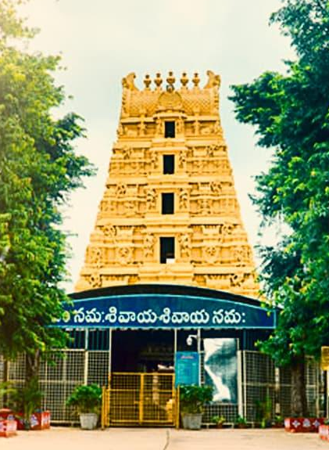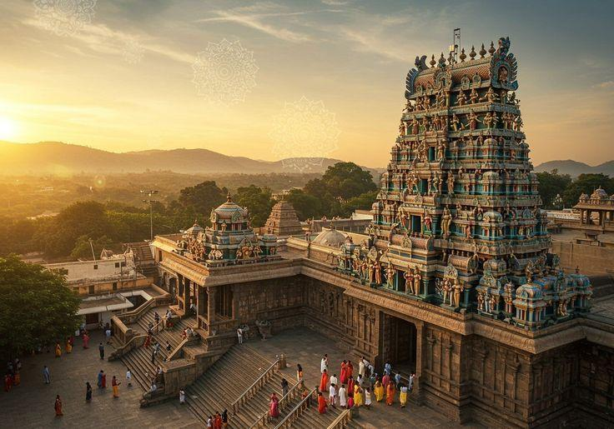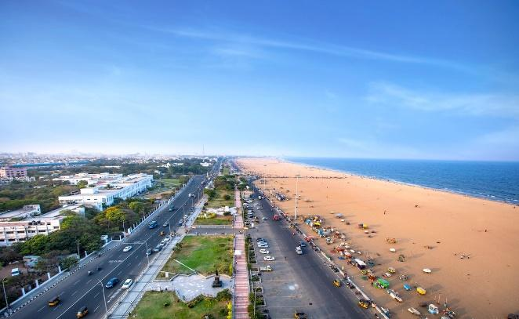

Route: Hyderabad → Srisailam → Tirupati → Chennai

DAY 01: ARRIVAL HYDERABAD – HYDERABAD CITY TOUR
Arrive at Hyderabad Airport / Railway Station and proceed for a city sightseeing tour.
Places to Visit:
- Charminar
- Mecca Masjid
- Chowmahalla Palace
- Salar Jung Museum
- Hussain Sagar Lake
- Birla Mandir
After sightseeing, check in to the hotel and relax.
Overnight Stay: Hyderabad

DAY 02: HYDERABAD – SRISAILAM
Approx. 215–230 km | 5–6 Hours
After breakfast, check out from the hotel and drive to Srisailam, passing through the scenic Nallamala Hills.
Upon arrival, check in to the hotel.
Later, proceed for pilgrimage visits:
Places to Visit:
- Sri Bhramaramba Mallikarjuna Swamy Temple
- Mallikarjuna Jyotirlinga Darshan
- Bhramaramba Devi Temple
In the evening, visit Srisailam Dam / Krishna River viewpoint, subject to timing and accessibility.
Overnight Stay: Srisailam

DAY 03: SRISAILAM – TIRUPATI
Approx. 370–400 km | 8–9 Hours
This is a long journey sector, so an early morning departure is recommended.
After an early breakfast, check out and drive towards Tirupati.
En route, optional short stops can be taken depending on the available time and road conditions.
Arrive in Tirupati by evening and check in to the hotel.
Evening at leisure for relaxation.
Overnight Stay: Tirupati
NOTE: Please be informed that the journey from Srisailam to Tirupati is approximately 370–400 km and may take around 8–9 hours by road, depending on traffic and road conditions. We therefore recommend an early morning departure from Srisailam and request guests to be prepared for a long driving day.

DAY 04: TIRUPATI – TIRUMALA DARSHAN
After an early breakfast, proceed to Tirumala for darshan.
Visit:
- Sri Venkateswara Swamy Temple
- Other important temples and viewpoints around Tirumala, subject to available time and temple timings
After darshan and sightseeing, return to Tirupati.
Evening at leisure.
Overnight Stay: Tirupati

DAY 05: TIRUPATI – CHENNAI
Approx. 135 km | 3–4 Hours
After breakfast, check out from the hotel and proceed towards Chennai.
En-route Optional Visit:
- Sri Kalahasti Temple – highly recommended for a pilgrimage-oriented itinerary
Continue the journey to Chennai.
Upon arrival, proceed for Chennai city sightseeing, subject to available time.
Places to Visit:
- Kapaleeshwarar Temple
- Marina Beach
- Fort St. George
- San Thome Basilica
Check in to the hotel and relax.
Overnight Stay: Chennai

DAY 06: CHENNAI DEPARTURE
After breakfast, check out from the hotel.
Depending on your departure schedule, enjoy some free time for shopping or leisure.
Later, proceed for your transfer to Chennai Airport / Railway Station for your onward journey.

TOUR ENDS |||||||

PACKAGE DETAILS:
PLACE | HOTEL 3 STAR
HYDERABAD | ADITYA HOMETEL
SRISILAM | GREEN HEAVEN
TIRUPATI | RAJ PARK TIRUPATI
CHENNAI | SABARI OMR

Pax | Cab | Special rate
For 2 Pax | Sedan | 29,000/- Per Person
For 4 pax | Ertiga | 23,800/- per person
For 6 pax | Tempo- 10 STR | 22,950/- per person

Validity: 01st October 26 – 31st March 27 (Not Valid on Peak dates like Pooja, Diwali, Pongal & Christmas Newyear dates)

COST INCLUDES
- Double share Accommodation in 3-star Hotel
- Sightseeing
- Daily breakfast at hotel
- Airport meet & greet, pick-up and drop
- English/ Hindi speaking driver throughout the trip
- Applicable Taxes
COST EXCLUDES
- Flight & Rail tickets
- Other meals, beverages, other than those mentioned in the inclusions
- Monument & Sightseeing Entrance Fee anywhere
- Camera Charges, Activity Fees & all other expenses which are in personal nature.
- Guide, Tour Escort (Can be provided up on request with extra Charges).
- Early Check in/ Late Checkout & Any Extra Meals.
- Any other item not specified in cost inclusions
Terms and Conditions

Terms & Conditions
Booking
Reservation Policy:
Hotel Timings
- Check-in Time: 15.00 Hours
- Check-out time: 12.00 Hours
Payment terms:
For the services contracted, 50% of total tour cost on booking to hold the booking on a confirmed basis and the balance amount should be paid before 30 Days of commencement of your tour. We hold the right to decide upon the amount to be paid as an advance payment, based on the nature of services and the time left for the commencement of the services. Apart from the above in some cases like International Tours, Flight Tickets, Visa, Special train journeys like Palace on Wheels, hotel or resort bookings during the high peak tourist season (X-Mas, New Year) full payment is required to be sent in advance.
Payment Options:
Payment can be made by Credit Card through our secured online payment gateway system, by Bank Transfer, Cash payment to our offices in your city or by Demand Draft / Cheque. All payments should be free and clear of any withholding tax and deduction. Bank charges, if any, for remittance (by remitting bank or by intermediary bank) would be strictly borne by payer.
Rights to amend the itinerary if required
Tour once commenced will strictly go as per the itinerary finalized. In case of events and circumstances beyond our control, we reserve the right to change all or parts of the contents of the itinerary for safety and wellbeing of our esteemed passengers.
Policy Regarding Cancellation / No Show / Early Departure
In case of cancellation of tour/travel services due to any avoidable/unavoidable reason/s we must be informed in writing. Cancellation charges would be effective from the date we receive letter in writing and cancellation charges would be as follows:

Period of Cancellation | Cancellation Charges
15 Days before departure | 50% of the Tour Cost
7 Days before Departure | 75% of the Tour Cost
Less than 7 Days before departure | 100% of the Tour Cost

Please note - Irrespective of above-mentioned cancellations slabs - in case of cancellation of tour services after the booking is made with us - a minimum 10% service charges would be applicable.

In case you cancel the trip after commencement refund would be restricted to a limited amount that too would depend on the amount that we would be able to recover from the hoteliers we patronize. For unused hotel accommodation, chartered transportation and missed meals etc. we do not bear any responsibility to refund.
Refund
In regard to refund of unused / unutilized services (which are paid for and cancelled in advance) the refund amount would be worked out on the basis of cancellation policy as described above and the money would be accordingly refunded to the person who has made the payment to us. Please note that the refund process may take 2 - 4 weeks due to banking procedures. If the refund is made to the credit card account OR to Bank account, the bank charges would be debited from the refund amount.
Our Liabilities & Limitations:
Please note that after the finalization of the tour/service cost, if there are any hikes in entrance fees of monuments/museums, taxes, fuel cost or guide charges by the Govt. of India, the same would be charged as extra.
All itineraries are sample itineraries, intended to give you a general idea of the likely trip schedule. Numerous factors such as weather, road conditions, the physical ability of the participants etc. may dictate itinerary changes either before the tour or while on the trail. We reserve the right to change any schedule in the interest of the trip participants' safety, comfort & general wellbeing.
Our rates are based on the prevailing rates as negotiated by us with the hotels, airlines etc. Hotels and Airlines retain the right to modify the rates without notice. In case of such changes the rates quoted before the modification, can be changed by us according to the modifications by hotels or airlines. All hotel bookings are based on usual check in and checkout time of the hotels until unless indicated in the itinerary.
We shall not be responsible for any delays & alterations in the programmed or expenses incurred - directly or indirectly - due to natural hazards, flight cancellations, accident, breakdown of machinery or equipment’s, breakdown of transport, weather, sickness, landslides, political closures or any untoward incidents.

We shall not be responsible for any loss, injury or damage to person, property, or otherwise in connection with any accommodation, transportation or other services, resulting - directly or indirectly - from any act of GOD, dangers, fire, accident, breakdown in machinery or equipment, breakdown of transport, wars, civil disturbances, strikes, riots, thefts, pilferages, epidemics, medical or custom department regulations, defaults, or any other causes beyond our control.
We do not have any insurance policy covering the expenses for accident, sickness, loss due to theft, or any other reasons. Visitors are advised to seek such insurance arrangements in their home country. All baggage & personal property/s at all times are at the client's risk.
Passports & Visas
To travel to India from overseas countries except for the citizen of Nepal & Bhutan, one needs a 06 months valid passport and a valid Visa. And processing of Passport and Visa are not included in the tour cost.
General Terms & Conditions
- The company reserves the right to postpone or cancel any of the tours advertised, without assigning any reason. In that case, money paid by the tour participant will be fully refunded but no compensation claim will be entertained.
- Due to certain unavoidable circumstances, the Company reserves the right to change / modify / vary and alter the tour itinerary if it becomes necessary. In such changes, compensations or claiming of refunds by the guests will not be entertained by the Company for limitation and also for the non- availability of certain services with entry tickets, restaurants, sightseeing shopping etc. even though included in tour itinerary.
- For Single passenger, without family, you will share a room either on twin or triple sharing basis (Roll away bed) depending on the booking. If we do not have a single person like you, then you will have to take the single supplement with an additional cost.
- The tariff of the tour quoted is calculated as per the rates prevailing at the time of quoting it. The Company reserves the right to change the tariff in the event of modification / alteration / change / variation in the said rates before the date of departure.
- Tour cost is based on minimum 30 passengers travelling together in the group. If there is a drastic fall in the number, then the offered meal plan, vehicle and other services may change accordingly.

- Company takes care to select hotels and book the same on behalf of tourists at convenient locations subject to availability. In case of non-availability of rooms in same hotel, Company has the right to split the accommodation in different hotels. Hotel accommodation is generally provided on Twin sharing basis in standard rooms and the third bed is often a roll-away mattress put in a twin-bedded room. Air-conditioning, central heating and other facilities are provided by the hotels depending upon various factors including weather / climatic conditions, local systems, tour type, etc.
- As a Tour Operator, the company does not have any control over Airlines, Coach Companies, Shipping Companies, Hotels, Local Transport or any other facilities, provided by the third parties. The company is not responsible for the delays or deficiencies in the services provided by outside agencies. Also please note that the company does not have any control on schedules of opening and closing timings of the tourist attractions.
- In computerized reservation system of Airlines seats once reserved cannot be changed. Tour participants will have to travel by the same seat provided by Airline.
- There are no refunds for any services, i.e. meals, sightseeing's, flight delay or cancellation of flight etc. not utilized on the tour.
- Group tour, Single passenger (without family), will have to share a room either on twin or triple sharing basis (Roll away bed) depending on the booking. If we do not have a single person like you, then you will have to take the single supplement with an additional cost.
- Group tours cost is based on minimum 30 passengers travelling together in the group. If there is a drastic fall in the number, then the offered meal plan, vehicle and other services may change accordingly.
- Adult Rate applicable per person on Double / Twin / Triple Sharing Room. Child Rate mentioned in the costing would be applicable only when the Child share the same room with Parents. If separate room required, Adult fare will be levied.
- upon various factors including weather / climatic conditions, local systems, tour type, etc.
- As a Travel House / Tour Operators, the company does not have any control over Airlines, Railways, Coach Companies, Shipping Companies, Hotels, Local Transport or any other facilities, provided by the third parties. The company is not responsible for the delays or deficiencies in the services provided by outside agencies. Also please note that the company does not have any control on schedules of opening and closing timings of the tourist attractions.
- In computerized reservation system of Indian Railways/Airlines, the berths / seats once reserved cannot be changed. Tour participants will have to travel by the same berth/seat as mentioned in the ticket, issued by Indian Railways/Airline.
- Any disputes arising in respect of the tour shall be subject to Ernakulum Jurisdiction.

******************

