Explore Vizag

Visakhapatnam, Araku Valley, Lambasingi

2 Nights/ 3 Days

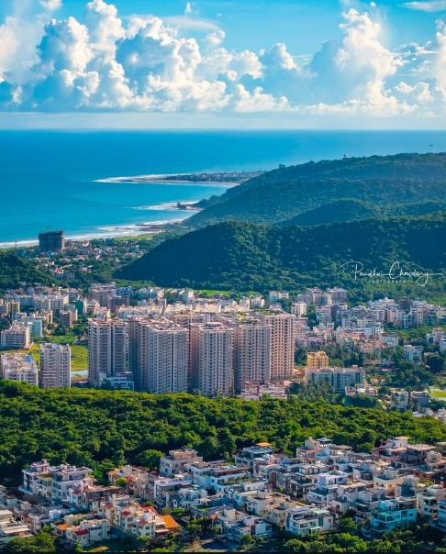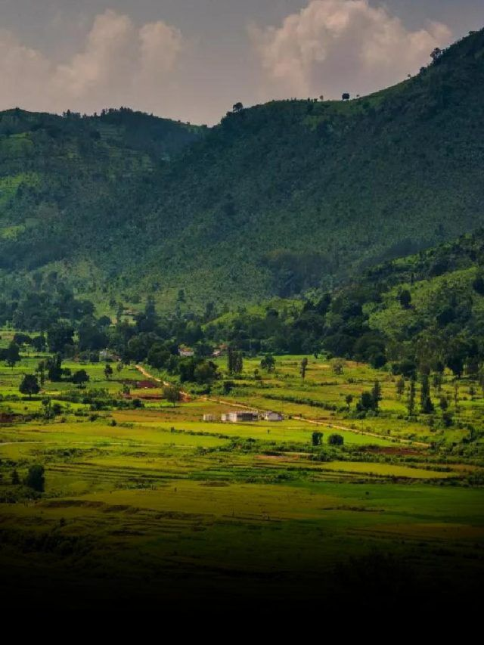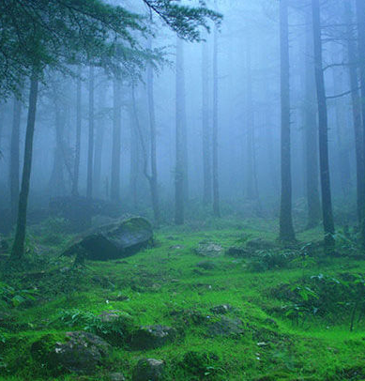

DAY 1: Welcome to Visakhapatnam, Where Hills Meet the Sea
On arrival at Visakhapatnam Airport, you will be warmly received by our representative and begin your local sightseeing tour. Start the day with a visit to the sacred Simhachalam Temple, nestled amidst lush green hills and known for its spiritual significance. Continue to Kailasagiri Hill Park, offering breathtaking panoramic views of the city, the coastline, and the endless blue of the Bay of Bengal. Later, explore the Indira Gandhi Zoological Park, home to diverse wildlife set in a natural forest environment. Visit the peaceful Sri Venkateswara Swamy Devalayam before unwinding at the golden shores of Rushikonda Beach, where the waves and sea breeze create a perfect moment of relaxation. Conclude the sightseeing with a visit to the INS Kurusura Submarine Museum, a unique reminder of India’s naval heritage. After a day filled with experiences, proceed to the hotel for check-in and enjoy an overnight stay in Visakhapatnam

DAY 2: Through Valleys, Caves, and Misty Hills
After breakfast, check out from the hotel and begin a scenic drive towards the beautiful Araku Valley, passing through the lush landscapes of the Eastern Ghats. Along the way, pause at Dumuku View Point to admire sweeping views of hills and deep valleys. Continue to the renowned Borra Caves, a natural wonder of ancient limestone formations shaped over centuries. Subject to water flow and accessibility, visit the refreshing Katiki Waterfalls, where cascading waters offer a moment of natural bliss. Stop at Galikonda View Point, one of the highest points in the region, for breathtaking panoramic vistas. Discover the rich flavors of the region at a local coffee plantation, followed by a visit to the Araku Tribal Museum, showcasing the culture, traditions, and art of indigenous communities. Stroll through the Botanical Garden and enjoy a sweet stop at the Chocolate Factory. As the day winds down, proceed to the cool and mist-covered hill village of Lambasingi. Upon arrival, check in at the hotel and relax amidst nature, enjoying an overnight stay in Lambasingi.
DAY 3: Misty Mornings and Fond Farewells
Begin the day early with a visit to the Lambasingi View Point, where gentle mist, cool mountain air, and golden sunrise hues create a magical start to the morning. Return to the hotel for breakfast and check out, then proceed to a nearby strawberry farm to experience the freshness of local hill produce. Continue to the serene Tajangi Reservoir, surrounded by rolling hills and quiet waters, offering a peaceful pause along the journey. Seek blessings at the Paderu Ammavari Temple, a revered shrine nestled amidst nature. Later, visit the beautiful Kottapalli Waterfalls, where cascading streams provide a refreshing finale to the hill adventure. As the journey comes to an end, proceed towards Visakhapatnam Airport for departure, carrying home sweet memories of scenic landscapes, culture, and unforgettable moments.

PACKAGE DETAILS:
PLACE | HOTEL 3 STAR | HOTEL 4 STAR | MEAL PLAN
Vizag | L j Grand | Dolphin Hotel | CP
Lambasingi | Hamza Hill Resort | Hamza Hill Resort | CP

Pax | Cab | Special rate
For 2 Pax | Sedan | 14,210/- Per Person
For 4 pax | Ertiga | 9,890/- per person
For 6 pax | Innova Crysta | 8,650/-per person

COST INCLUDES
- Double share Accommodation in 3-star Hotel
- Sightseeing
- Daily breakfast at hotel
- Airport meet & greet, pick-up and drop
- English/ Hindi speaking driver throughout the trip
- Applicable Taxes
COST EXCLUDES
- Flight & Rail tickets
- Other meals, beverages, other than those mentioned in the inclusions
- Monument & Sightseeing Entrance Fee anywhere
- Camera Charges, Activity Fees & all other expenses which are in personal nature.
- Guide, Tour Escort (Can be provided up on request with extra Charges).
- Early Check in/ Late Checkout & Any Extra Meals.
- Any other item not specified in cost inclusions

Terms and Conditions

Terms & Conditions
Booking
Reservation Policy:
Hotel Timings
- Check-in Time: 15.00 Hours
- Check-out time: 12.00 Hours
Payment terms:
For the services contracted, 50% of total tour cost on booking to hold the booking on a confirmed basis and the balance amount should be paid before 30 Days of commencement of your tour. We hold the right to decide upon the amount to be paid as an advance payment, based on the nature of services and the time left for the commencement of the services. Apart from the above in some cases like International Tours, Flight Tickets, Visa, Special train journeys like Palace on Wheels, hotel or resort bookings during the high peak tourist season (X-Mas, New Year) full payment is required to be sent in advance.
Payment Options:
Payment can be made by Credit Card through our secured online payment gateway system, by Bank Transfer, Cash payment to our offices in your city or by Demand Draft / Cheque. All payments should be free and clear of any withholding tax and deduction. Bank charges, if any, for remittance (by remitting bank or by intermediary bank) would be strictly borne by payer.
Rights to amend the itinerary if required
Tour once commenced will strictly go as per the itinerary finalized. In case of events and circumstances beyond our control, we reserve the right to change all or parts of the contents of the itinerary for safety and wellbeing of our esteemed passengers.

Policy Regarding Cancellation / No Show / Early Departure
In case of cancellation of tour/travel services due to any avoidable/unavoidable reason/s we must be informed in writing. Cancellation charges would be effective from the date we receive letter in writing and cancellation charges would be as follows:

Period of Cancellation | Cancellation Charges
15 Days before departure | 50% of the Tour Cost
7 Days before Departure | 75% of the Tour Cost
Less than 7 Days before departure | 100% of the Tour Cost

Please note - Irrespective of above-mentioned cancellations slabs - in case of cancellation of tour services after the booking is made with us - a minimum 10% service charges would be applicable.
In case you cancel the trip after commencement refund would be restricted to a limited amount that too would depend on the amount that we would be able to recover from the hoteliers we patronize. For unused hotel accommodation, chartered transportation and missed meals etc. we do not bear any responsibility to refund.
Refund
In regard to refund of unused / unutilized services (which are paid for and cancelled in advance) the refund amount would be worked out on the basis of cancellation policy as described above and the money would be accordingly refunded to the person who has made the payment to us. Please note that the refund process may take 2 - 4 weeks due to banking procedures. If the refund is made to the credit card account OR to Bank account, the bank charges would be debited from the refund amount.
Our Liabilities & Limitations:
Please note that after the finalization of the tour/service cost, if there are any hikes in entrance fees of monuments/museums, taxes, fuel cost or guide charges by the Govt. of India, the same would be charged as extra.
All itineraries are sample itineraries, intended to give you a general idea of the likely trip schedule. Numerous factors such as weather, road conditions, the physical ability of the participants etc. may dictate itinerary changes either before the tour or while on the trail. We reserve the right to change any schedule in the interest of the trip participants' safety, comfort & general wellbeing.
Our rates are based on the prevailing rates as negotiated by us with the hotels, airlines etc. Hotels and Airlines retain the right to modify the rates without notice. In case of such changes the rates quoted before the modification, can be changed by us according to the modifications by hotels or airlines. All hotel bookings are based on usual check in and checkout time of the hotels until unless indicated in the itinerary.
We shall not be responsible for any delays & alterations in the programmed or expenses incurred - directly or indirectly - due to natural hazards, flight cancellations, accident, breakdown of machinery or equipment’s, breakdown of transport, weather, sickness, landslides, political closures or any untoward incidents.
We shall not be responsible for any loss, injury or damage to person, property, or otherwise in connection with any accommodation, transportation or other services, resulting - directly or indirectly - from any act of GOD, dangers, fire, accident, breakdown in machinery or equipment, breakdown of transport, wars, civil disturbances, strikes, riots, thefts, pilferages, epidemics, medical or custom department regulations, defaults, or any other causes beyond our control.
We do not have any insurance policy covering the expenses for accident, sickness, loss due to theft, or any other reasons. Visitors are advised to seek such insurance arrangements in their home country. All baggage & personal property/s at all times are at the client's risk.
Passports & Visas
To travel to India from overseas countries except for the citizen of Nepal & Bhutan, one needs a 06 months valid passport and a valid Visa. And processing of Passport and Visa are not included in the tour cost.
General Terms & Conditions
- The company reserves the right to postpone or cancel any of the tours advertised, without assigning any reason. In that case, money paid by the tour participant will be fully refunded but no compensation claim will be entertained.
- Due to certain unavoidable circumstances, the Company reserves the right to change / modify / vary and alter the tour itinerary if it becomes necessary. In such changes, compensations or claiming of refunds by the guests will not be entertained by the Company for limitation and also for the non- availability of certain services with entry tickets, restaurants, sightseeing shopping etc. even though included in tour itinerary.
- For Single passenger, without family, you will share a room either on twin or triple sharing basis (Roll away bed) depending on the booking. If we do not have a single person like you, then you will have to take the single supplement with an additional cost.
- The tariff of the tour quoted is calculated as per the rates prevailing at the time of quoting it. The Company reserves the right to change the tariff in the event of modification / alteration / change / variation in the said rates before the date of departure.
- Tour cost is based on minimum 30 passengers travelling together in the group. If there is a drastic fall in the number, then the offered meal plan, vehicle and other services may change accordingly.
- Company takes care to select hotels and book the same on behalf of tourists at convenient locations subject to availability. In case of non-availability of rooms in same hotel, Company has the right to split the accommodation in different hotels. Hotel accommodation is generally provided on Twin sharing basis in standard rooms and the third bed is often a roll-away mattress put in a twin-bedded room. Air-conditioning, central heating and other facilities are provided by the hotels depending upon various factors including weather / climatic conditions, local systems, tour type, etc.

******************

